Smart Helmet

**Introduction**

Nowadays road accidents are undoubtedly the most frequent and that cause a very serious damages and deaths. Among those, number of accidents happen by motor cycles are rising day by day. In those situations, deaths happen due to the delay for emergency services to reach exact location of incident with lack of emergency treatments. So far for this problem we have come up with a successful solution for people who ride motorbikes.

**Scope of the project**

The main scope of this project is to reduce deaths cause by road accidents, by developing a smart helmet unit to inform emergency services in case of a accident or a emergency situation reducing the time for emergency service to reach the location.

**Basic operation and technical features of the helmet**

In talking about basic operation of the helmet in case of an accident was happened while riding the bike the unit attached to the helmet sends a Bluetooth signal to the smartphone. Then the android app finds out the current GPS location and sends it to an emergency service. Furthermore, user can manually send an emergency message to seek help in case of an emergency except of an accident.

**Technologies, we are using**

In this project mainly, we are using Internet of things, Android and Cloud. Inside the main control unit, we have used an Arduino microcontroller, impact detecting sensor, IMU (Inertial measuring unit) sensor and a Bluetooth module. Here impact detecting sensor is used to detect a high impact or a shock in case of an accident. IMU is used to calculate the speed and sudden change of the acceleration in a high impact. The importance of using a IMU sensor is to make sure if the impact was happened with a motion to avoid any unwanted activation of system along with shock.

In this prototype version we have used an android app to keep the connectivity between the helmet and smartphone via Bluetooth. As soon as the helmet detects an accident it sends a Bluetooth signal to the mobile phone. As soon as the signal received, it turns on the GPS and find out the exact GPS point of the location. Then sends a SOS message including name of the person who met with an accident, time of the accident happened, location and other relevant details location to an Emergency service and to three pre- saved mobile numbers. Then using cloud, it saves all of these details in a web app that can be used as a proof.

**Hardware specifications**

* AVR family microcontroller(Arduino)
* Shock detecting sensor
* IMU sensor
* Resistors
* Capacitors
* Diodes

**Arduino UNO**

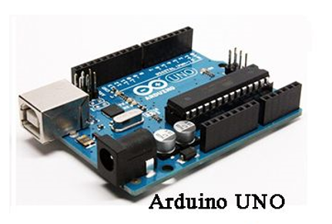

Microcontrollers can be termed as a single on chip computer that contains number of hardware aspects like RAM, EEPROM, Timers etc., that can be programmed to perform a predefined task. Here in this project we are using a AVR family microcontroller to perform this task.

**Sensors**

Sensors are kind of electronic hardware elements that are sensitive to changes in physical environment and they can convert those changes into electronic signals that can be used for a meaningful purpose. Those changes may be light, heat, acceleration, humidity, pressure or any other kind of a environmental phenomenon.

**Shock detecting sensor(ADXL377)**

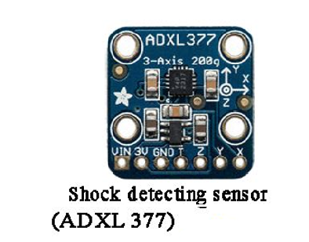

Shock detecting sensor is used to sense high impact in a collision. Here the sensor of ADXL 377, we have supposed to use has a minimum sensitivity of 200g.

**IMU Sensor**

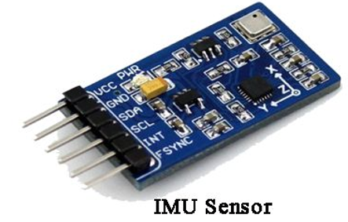

IMU sensor (inertial measuring unit) is used to measure acceleration and speed.

**Bluetooth module(HC05)**

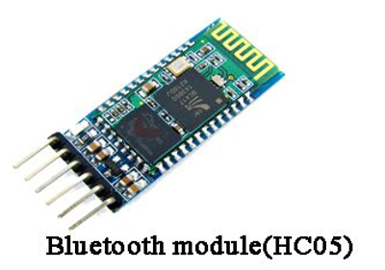

Bluetooth module is used to keep the connectivity between smart phone and the unit attached to the helmet

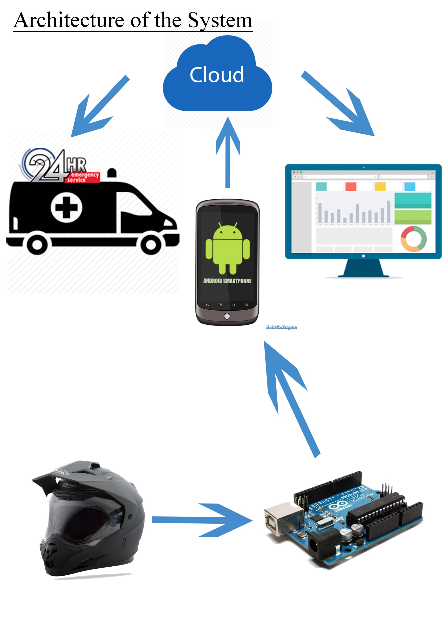

**Flow chart**

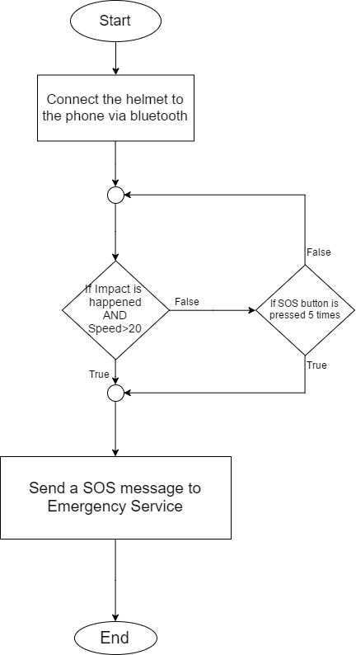

**Benefits of this project**

There are several benefits of this project. Mainly it reduces the time for emergency service to reach the accident location giving more opportunity save the life of the rider. Furthermore, user can use this unit separately for other kind of an emergency situation just like a robbery. In addition to that saved data in the cloud of the user and location can be used as a proof

**Conclusion**

In Sri Lanka, the number of road accidents and deaths happens from motor cycles are increasing day by day. So the main target of our project is to reduce deaths happens from road accidents by minimizing the time for emergency services to reach the location of accident by using latest technologies if IOT, Android and cloud computing.